1. In our last lecture, we configured circuit breaker pattern.
2. Let’s run some applications.
   1. 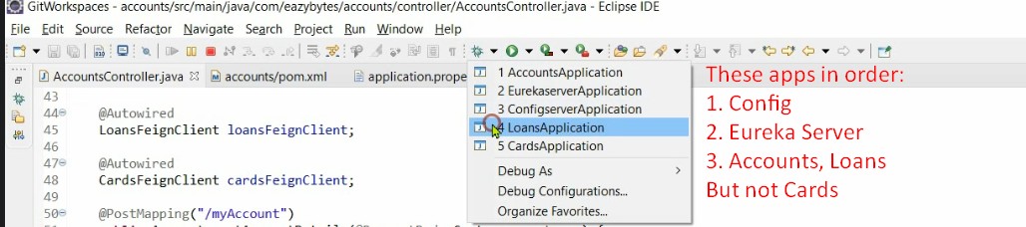
   2. We didn’t run Cards microservice to simulate the scenario where we will see how circuit breaker behaves if one service doesn’t work.
3. 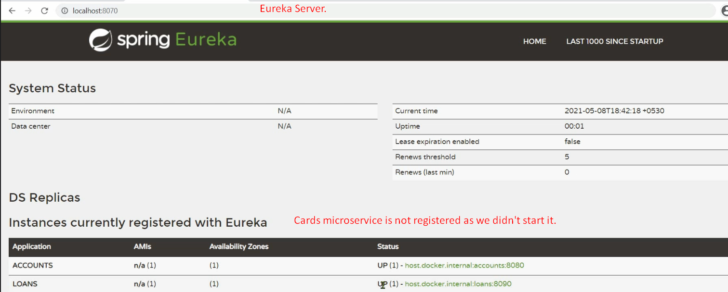
4. In last lecture, we configured a property where circuit breaker will register itself with actuator so that we can see what is happening behind the scene.
5. Let’s open the actuator endpoints.
6. 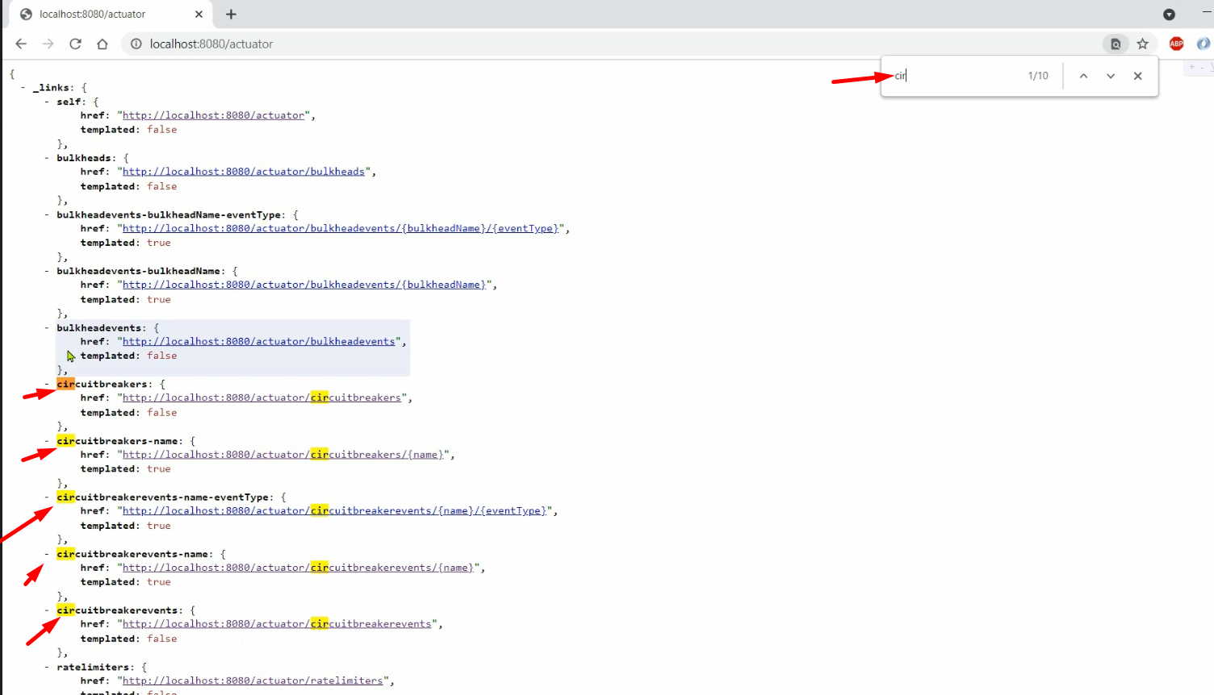
7. 
   1. 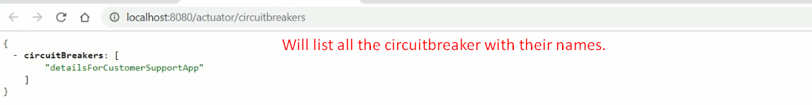
8. 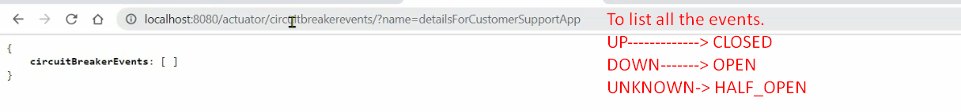
9. Let’s go the postman to invoke the API.
10. Before that remember. Threshold is 50% and Minimum calls are 5 times to decide whether Circuit should go from CLOSED to OPEN state. 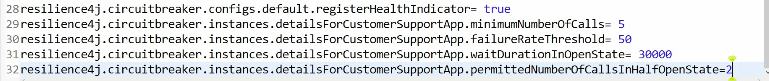
11. 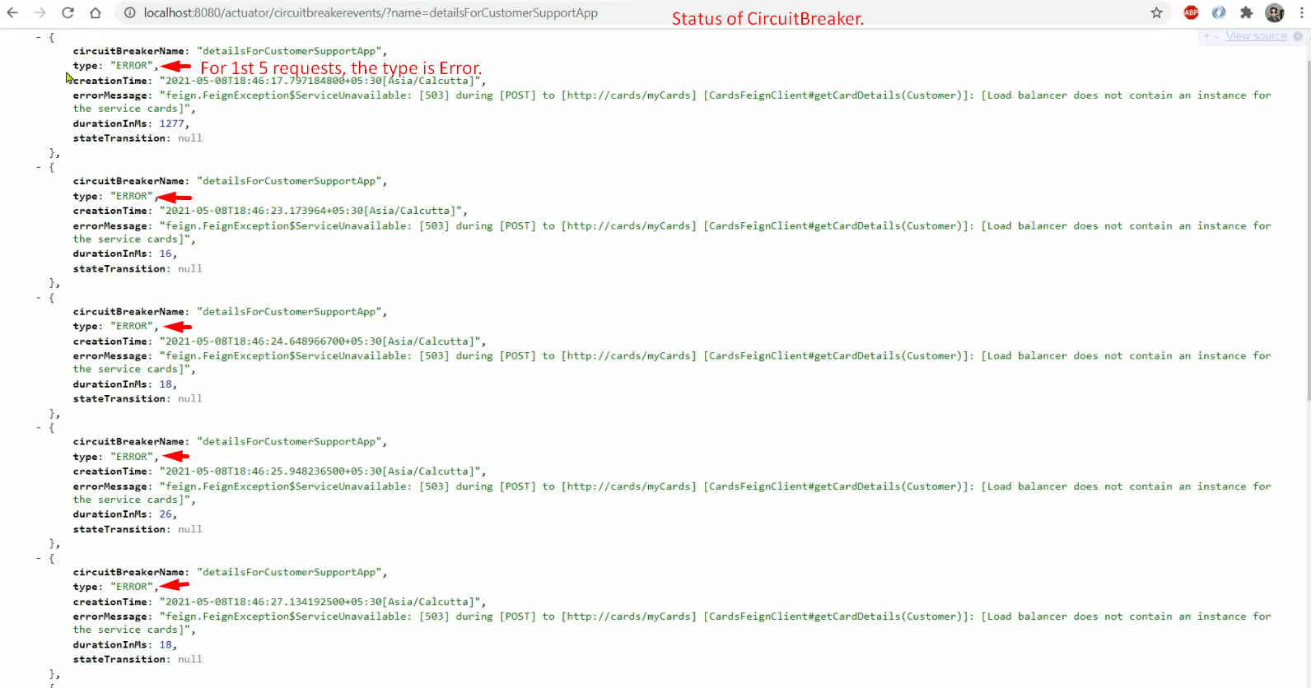
12. 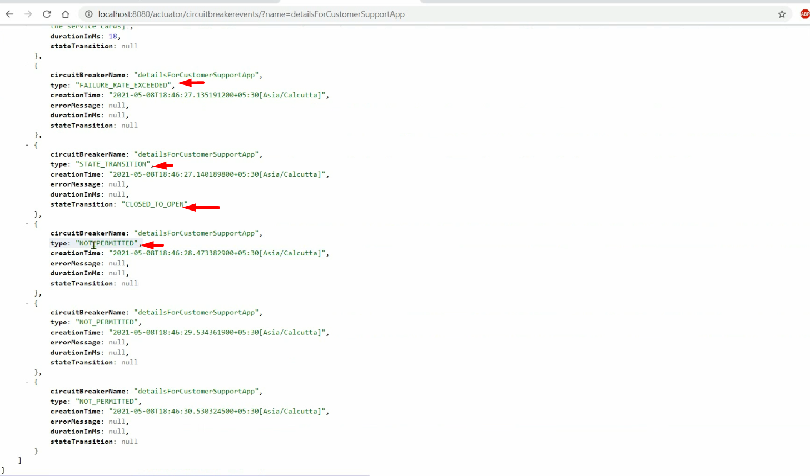  
    During the open state, if we make any request and no fallbackMethod, then exception is thrown by circuit breaker without calling the method annotated with @CircuitBreaker.  
    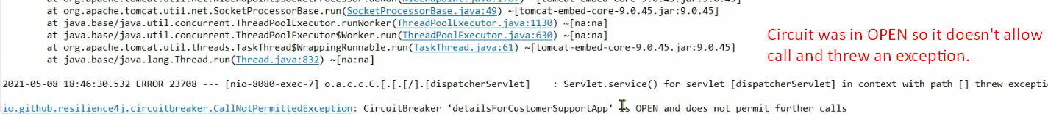
13. After 30 seconds, the circuit breaker will go from OPEN to HALF_OPEN state.  
    Then it will allow 2 requests. 